**The Doctor Appointment Project:**

**Data Base design using (AWS Aurora MySQL):**

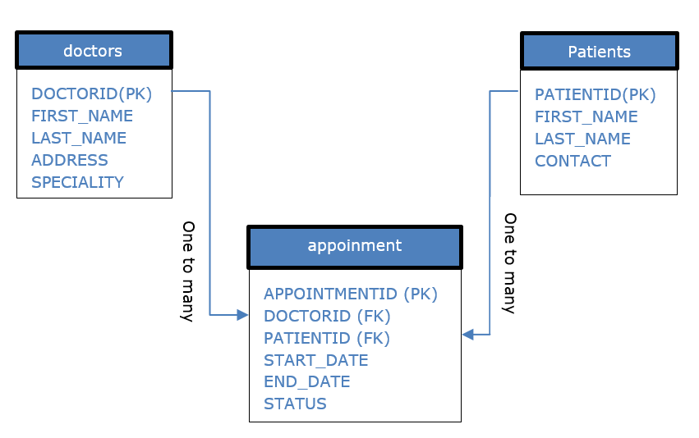

**Project UML:**

